- Write a program in Java to demonstrate use of this keyword. Check whether this can access the private members of the class or not.
- Design a class as shown in figure
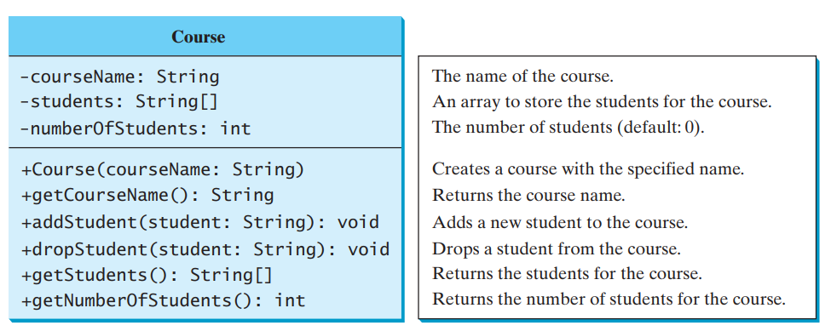
- Write a program in Java to develop overloaded constructor.
- Write a java program for given scenario
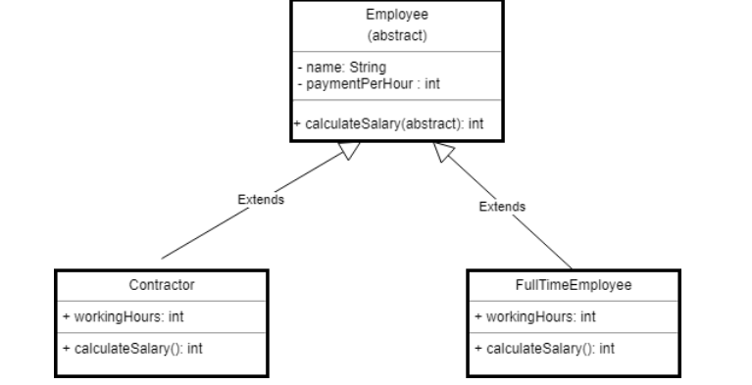
- Write a program in Java to demonstrate multilevel inheritance in Java
- Write a program in Java in which a subclass constructor invokes the constructor of the super class and instantiate the values.
- Describe abstract class called Shape which has three subclasses say Triangle, Rectangle, Circle. Define one method area() in the abstract class and override this area() in these three subclasses to calculate for specific object i.e. area() of Triangle subclass should calculate area of triangle etc. Same for Rectangle and Circle
- Re-write program 4 and 7 to use Interface instead of Abstract class.
- Write a Java program to demonstrate multiple inheritance using interface.
- Read the following tutorial about Math class and implement all programs given at the following link: https://docs.oracle.com/javase/tutorial/java/data/beyondmath.html
- The following program demonstrates the use of GregorianCalendar class. Type this code and observe the output.
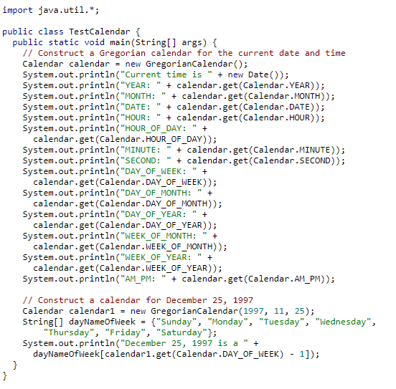
- Write a program to display a calendar for a specified month using the Calendar and GregorianCalendar. Your program receives the month and year as input.
